**NAME : *Utkarsh Tambe*** **REG NO. : *RA2011027010166***

**1. Exercise** : **1** **2. Date:** *13th**October, 2020.*

**

1. **Title** : Essentials of engineering graphics Introduction and basics
2. **Aim**: To know the importance of Engineering Graphics, standards, lettering; and to draw simple 2D objects in CAD software.
3. **Software used**:*AutoDesk AutoCAD 2021.*
4. **Introduction**:



**i. About Engineering Graphics:**

*Engineering graphics is the creation of engineering drawings.*

*These are representations of physical objects/locations on paper.*

*The purpose of an engineering drawing is to clearly and accurately capture all geometric features of a product or component so that a manufacturer or engineer can produce the required item.*

**

**ii. About Drafting tools and its advantages over conventional drafting:**

*AutoCAD is significantly faster than the traditional method of manual drafting. It accelerates the task of preparing a bill, reports, scaling etc. of content-tedious work of drawing each lines on paper done in a few mouse clicks. As CAD software removes repeated iterations and large amount of time is conserved.*

**

1



1. **Procedure** (for solving question) :

**7.1** Question outline:*To write capital and small letters from A-Z.*

**7.2** Object:*Draw different shapes ( polygons, circle etc. ).*

**7.3** Conditions (if any):*Letters should be of given height and width.*

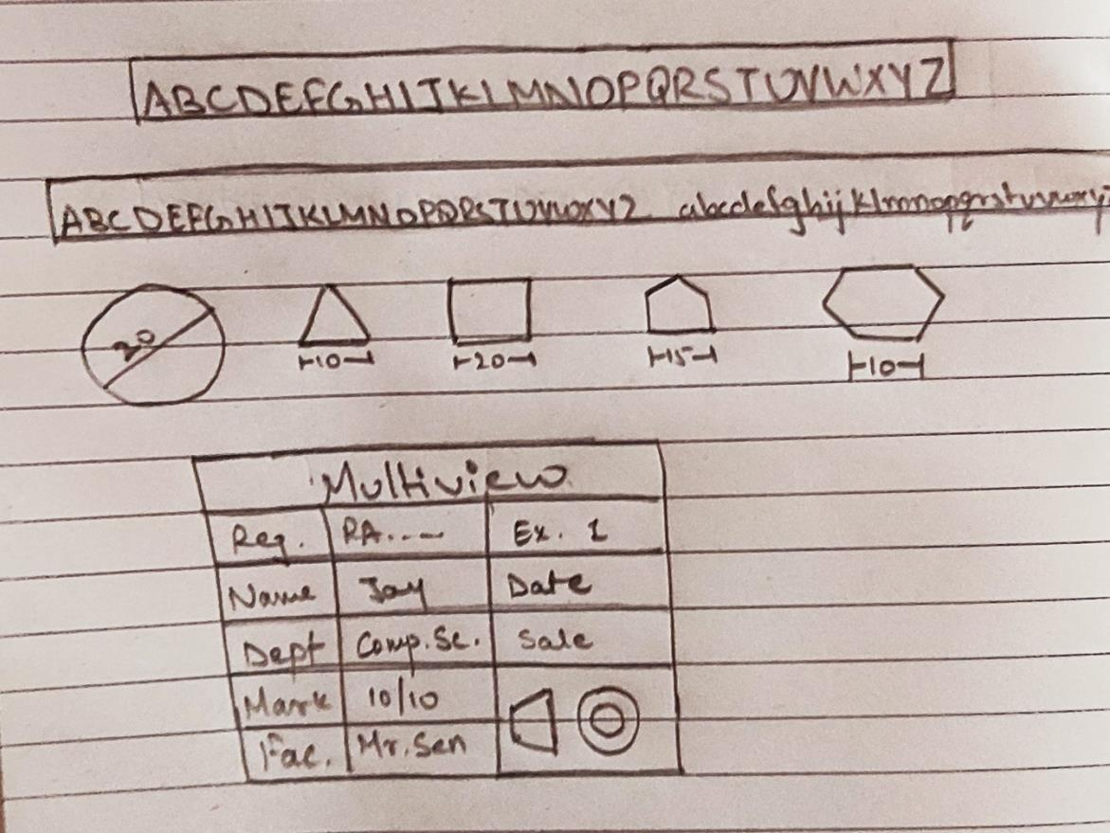

**Fig.** **Free hand sketch of the solution to question #**

**7.4 Drawing Procedure**:



**Step 1.**

*Firstly we will use “UNITS” command to set precision at 0 and unit at millimetre. Then we will set decide of work area to 0 X 0 to*

2



*297 X 210 by using the command “LIMIT”. then we use the command “ZOOM” and write all to zoom into work area. We will set the font and height and width of text using command “STYLE”.*

**Step 2.**

*By using command ‘LINE’ draw two box of dimension 100 X 7 and by using the command ‘TEXT’ in one box write Capital letters from A-Z of height 7 and width 0.7 and in the other box write capital letters from A-Z and small letters from a-z of height 5 and width 0.5 .*

**Step 3.**

*By using the command “CIRCLE” and “POLYGON” we make circle of our desired diameter and polygon of n-side. Now to make a title block we make a rectangle of the given dimension and draw horizontal lines in it at a distance of 10mm each and draw a vertical line 50mm apart from right and 40mm apart from left. Write the text in them with the help of text command.*

**

|  |  |  |
| --- | --- | --- |
| **8. Commands used**: | |  |
| **S.N.** | **Command** | **Use** |
| 1. | *UNITS* | *Used to set unit type and precision.* |
| 2. | *LIMITS* | *Define the workspace and give it a* |
|  |  | *boundary.* |
| 3. | *STYLE* | *Help us to set font type, height, width.* |
| 4. | *LINE* | *Used to draw line of 'n' units.* |
| 5. | *TEXT* | *Used to write a text.* |
| 6. | *CIRCLE* | *Used to draw a circle.* |

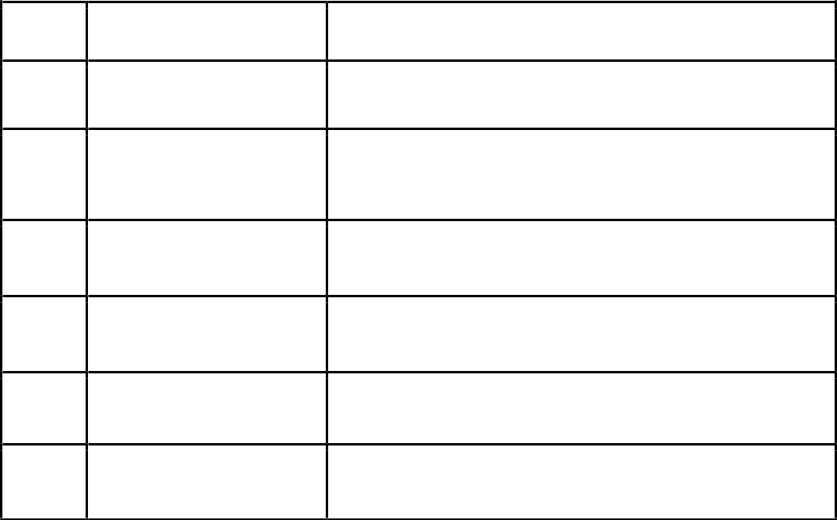

3



|  |  |  |
| --- | --- | --- |
| 7. | *POLYGON* | *Used to draw a polygon of n-sides.* |
| 8. | *OFFSET* | *Help us to copy any object at a* |
|  |  | *distance of x from it.* |
| 9. | *TRIM* | *Used to remove any undesired line.* |
| 10. | *DIM* | *Used to write the dimension of the* |
|  |  | *objects.* |

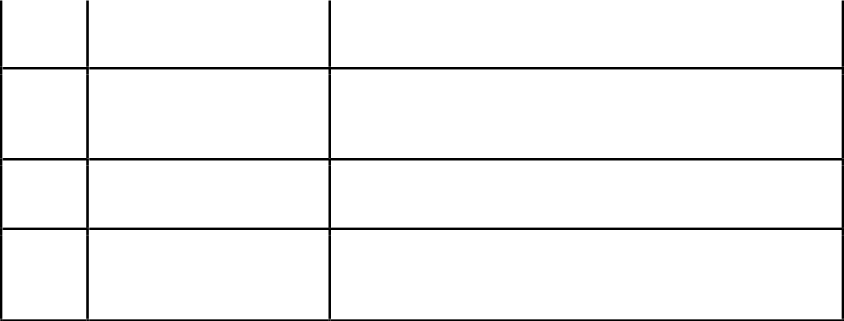

**9. Result:**

*Thus, by the use of AUTOCAD we were able to write the letters, draw shapes and create a title block in 2-Dimension.*

**

|  |  |
| --- | --- |
| **Faculty Name** | **Date of Submission** |

**Signature** **Marks**